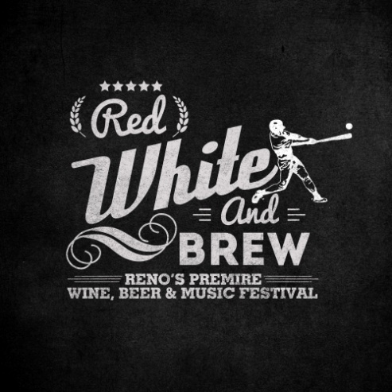

Red, White & Brew

Sponsorship Opportunities
Save the date for the inaugural Red White & Brew Summer’s Beer, Wine and Music Festival at Ace’s Stadium on August 16th 2014. Be a part of this unique festival where craft beer and wine come together with great music for the beer, wine and music connoisseurs alike. Don’t miss this opportunity to promote your business and gain exposure in this niche market. Festival attendees will have fun tasting and listening to great music provided by Jakes Garage 5.0, Steel Breeze and headlining act The Novelist. This signature event is the first of its kind at the renowned Aces Ball Stadium. The Festival begins at 1PM and wraps up at 8PM. The estimated attendance is 2000 people throughout the event. This event will be mass marketed on Radio, TV, Print, and active Social Media networks. To encourage quality control and equal coverage RWB promotions will have a check off card that will be collected at the conclusion of the event good for a drawing.

Wine and Beer Sponsorships

Wine Provider Sponsorship
Provide 2oz tastings for approximately 2000 people in your most popular and desired varietals. Booth staff to pour.
Receive the following:
- 8’ft Banquet Table w/ top and skirt
- All glassware will be provided by promoter
- Included in program & map
- Bio listed on website page with your specific information include
- Banner space at point of tasting
- Shared promotional inclusion and logo in social media, print and radio
- Opportunity to sell offsite Wine Club Memberships, bottles and cases

Beer Provider Sponsorship
Provide 2oz tastings for approximately 2000 people in your most popular and desired varietals. Booth staff to pour .
Receive the following:
- 8’ft Banquet Table w/ top and skirt
- All glassware will be provided by promoter
- Included in program & map
- Bio listed on website page with your specific information include
- Banner space at point of tasting
- Shared promotional inclusion and logo in social media, print and radio
- Increased database and awareness

Event & Vendor Sponsorships
$10,000 Level
Event Title Sponsor
This event will be” presented by “your business
Event Title level will receive the following:
- Company name and logo will be featured on all advertising and promotions, including Radio, newspaper, social media, event banners, printed materials, email blasts and text blast, stage announcements.
- Included in a minimum of 600 promotional announcements on Cumulus radio stations
- Rotating logo/ad on the scoreboard throughout the day
- 20 tickets to the event ($1080 value) and 6 VIP tickets( $600 value)
- Linkable logo to all 4 Cumulus websites on the Red, White & Brew splash page
- Business name on the General Admission Tickets
- Full page ad on the back cover of the event program
- Banner placement on both sides of the stage
$6,000 Level
Wine Bar Title Sponsor
This event will be presented by “your wine bar” in all promotional materials.
Each $6,000 level will receive the following:
- Company name and logo will be featured on all advertising and promotions, including Radio, newspaper, social media, event banners, printed materials, email blasts and text blast, stage announcements.
- Included in a minimum of 600 promotional announcements on Cumulus radio stations ($30,000 Value)
- Rotating logo/ad on the scoreboard throughout the day
- 14 tickets to the event ($540 value) and 6 VIP tickets( $600 value)
- Linkable logo to all 4 cumulus websites on the Red, White & Brew splash page
- 1/2page ad in event program
- All wines and beers served will be featured in the event program
- Banner placement in front of the stage

$2500 Level
Each $2,500 level will receive the following:
- 20’x 60 space in front of aces ball park or 10x 30 space inside ace’s concourse
- 6 tickets to the event ($270 value) and 2 VIP tickets ($200 value)
- Rotating logo/ad on the scoreboard throughout the day
- Banner space inside venue
- Linkable logo to all 4 cumulus websites

Auto Dealer Sponsor
Trailer Sponsor
R.V Sponsor
Pool/Spa Sponsor
BBQ Sponsor
Furniture Sponsor
Motorcycle Sponsor
Marine Sponsor
Other Opportunities

Exclusive VIP Area Sponsor
Each $4,000 level will receive the following:
- Space inside the VIP Area at the event
- 6 tickets to the event ($270 value) and 2 VIP tickets ($200 value)
- Rotating logo/ad on the scoreboard throughout the day
- Banner space inside venue
- Linkable logo to all 4 cumulus websites

Gold sponsor $800
- Premium exhibit space of 10x10’
- 6 tickets to the event
- Banner space in one location at the event
- Linkable logo to all 4 cumulus websites
Sliver sponsor $600
- Exhibit space of 10x10’
- 4 ticket to the event
- Linkable logo to all 4 cumulus websites
Bronze Sponsor $380
- Exhibit space of 10x10’
- 2 ticket to the event

Intent to Participate: ___________________________________________________

Level of Sponsorship:____________________________________________________

Agreement to follow

